17.95: a) 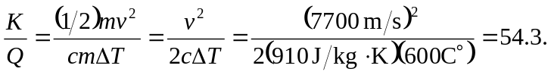
b) Unless the kinetic energy can be converted into forms other than the increased heat of the satellite cannot return intact.

